LAB 06: Logging with SLF4J

Open the starter code:
  - Download the starter code of Lab 06 (file lab06.rar) from the course website.
  - Unzip the file into your eclipse workspace.
  - Open eclipse and import your project using “import an existing Maven project”.
  - Open the first package containing the main App.java file.

Add dependencies to SLF4J
Add the SLF4J dependency:
<dependency>
<groupId>org.slf4j</groupId>
<artifactId>slf4j-api</artifactId>
<version>2.0.16</version>
</dependency>

SLF4J is an abstraction to logging libraries, it does not have a concrete implementation of the logging functionality. It is a façade to other concrete libraries.

Test the logging functionality:
  - Create a static property for a Logger (from org.slf4j) object in your main class (you may need to right click of the pom.xml -> Maven -> Update project to force Maven to reload the pom.xml).
// replace MainClassName by the name of your class
static Logger logger = LoggerFactory.getLogger(MainClassName.class);
  - Log an information message that the application is starting where appropriate:
logger.info("Application is starting...");
  - Run the application using the plugin that is declared in your pom.xml (clean package exec:java).
  - A warning message should be displayed: (No SLF4J providers were found.)
Note: We have to also add a dependency to a concrete logging library.

Add a dependency to the logback library
  - Open your pom.xml and add a dependency to logback using the user interface:
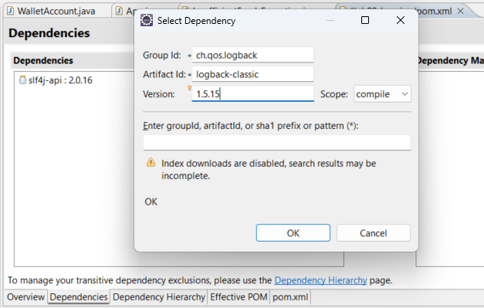

  - Re-run your application and check that you have the right logging message now:
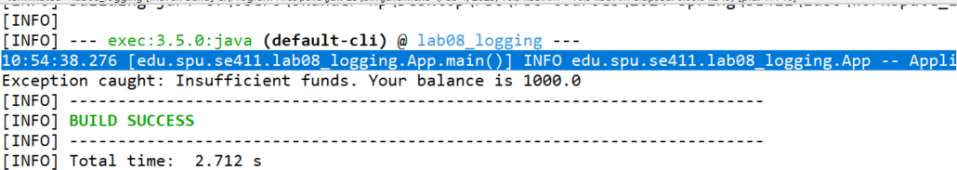

Using another library then logback: log4j12
  - Remove the previously added dependency to logback.
  - Add a new dependency to log4j12:
Group id | org.slf4j
Artifact id | slf4j-log4j12
Version | 2.0.16
  - Log4j needs a configuration file to work properly: Add a new file under src/main/resources, called log4j.properties.
  - In this file configure how the logger will work:

log4j.rootLogger = ERROR, LOG1 | We configure the minimum displayed level (lower levels are ignored), and we create a logger called LOG1
log4j.appender.LOG1=org.apache.log4j.FileAppender | We configure our logger to log in a file
log = ./logs/App/log4j  log4j.appender.LOG1.File=${log}/log.out | specify output file name
log4j.appender.LOG1.layout=org.apache.log4j.PatternLayout  log4j.appender.LOG1.layout.conversionPattern=%d %p [%t] %C - %m%n | We configure the format of output logged messages:  %d: timestamp  %p: priority  %t: thread  %C: the class  %m: the message  %n: return character

  - Re-execute the program, you should see no logged messages. Change the minimum logged level to INFO and re-execute. You should see the logged message in the right format.

Add the following logging messages:
Event | Log level
Application starts, Application ends | info
Wallet account created | debug
Deposit, withdraw | debug
InsufficientFundsException object created | warn
thrown exception | error

- Finally, change the log level and re-execute your code to see what messages are logged.
- Use AI to evaluate your logging strategy.
- Apply AI recommendations to improve your logging strategy.

END

